Bellman-Ford algorithm:

1. This step initializes distances from source to all vertices as infinite and distance to source itself as 0. Create an array dist[] of size |V| with all values as infinite except dist[src] where src is source vertex.
2. This step calculates shortest distances. Do following |V|-1 times where |V| is the number of vertices in given graph.  
   **a)** Do following for each edge u-v

If dist[v] > dist[u] + weight of edge uv, then update dist[v]

dist[v] = dist[u] + weight of edge uv

1. This step reports if there is a negative weight cycle in graph. Do following for each edge u-v

If dist[v] > dist[u] + weight of edge uv, then “Graph contains negative weight cycle”

The idea of step 3 is, step 2 guarantees shortest distances if graph doesn’t contain negative weight cycle. If we iterate through all edges one more time and get a shorter path for any vertex, then there is a negative weight cycle.

Example:

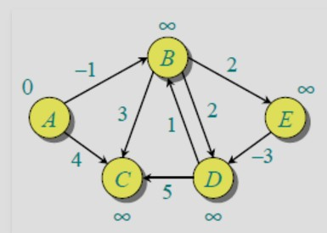

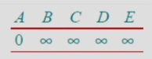 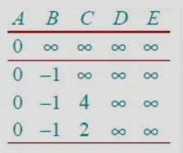 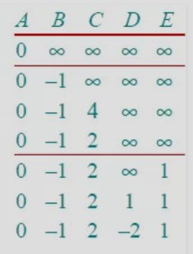

Let the given source vertex be 0. Initialize all distances as infinite, except the distance to source itself. Total number of vertices in the graph is 5, so all edges must be processed 4 times.

Let all edges are processed in following order: (B,E), (D,B), (B,D), (A,B), (A,C), (D,C), (B,C), (E,D). We get following distances when all edges are processed first time. The first row in shows initial distances.

The first iteration guarantees to give all shortest paths which are at most 1 edge long. We get following distances when all edges are processed second time

The second iteration guarantees to give all shortest paths which are at most 2 edges long. The distances are minimized after the second iteration, so third and fourth iterations don’t update the distances. (The last row shows final values)

Complexity :

Computational complexity is the study of the inherent limits of efficient computation measured in terms of time, space, and other resources such as randomness.

|  |  |  |  |  |  |
| --- | --- | --- | --- | --- | --- |
|  |  | Negative edges | Negative  cycle | Time complexity | Space complexity |
| Dijkstra | Single source | NO | NO | O(Vlog V+E) | O(V+E) |
| Bellman-Ford | Single source | YES | YES | O(V.E) | O(V) |

Chart of experimental values:

We have calculated some experimental values by this configuration’s pc like as:

Ankur tor pc config bosa eidike

|  |  |  |
| --- | --- | --- |
| No of Nodes | Dijkstra’s (sec) | Bellman ford’s (sec) |
| 1000 | 0.02354 | 0.02355 |
| 5000 | 0.5337 | 0.5539 |
| 10000 | 2.1728 | 2.3027 |
| 15000 | 5.04 | 5.71 |
| 20000 | 9.1839 | 9.5033 |
| 30000 | 20.73 | 23.2003 |
| 50000 | 55.3941 | 75.4112 |

According to this chart we can get this: